



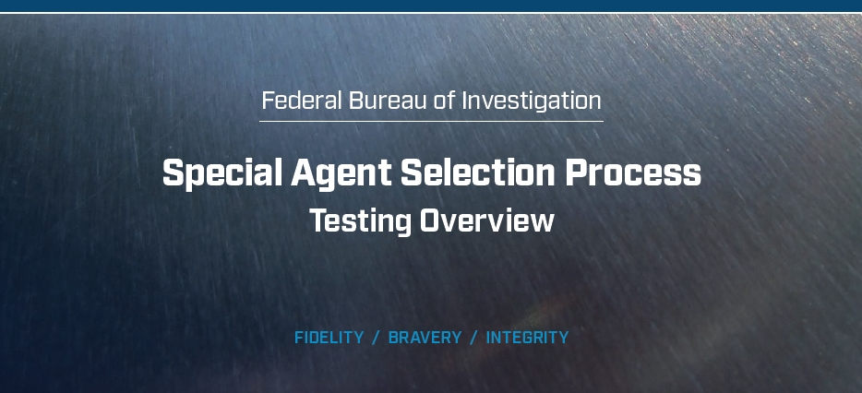

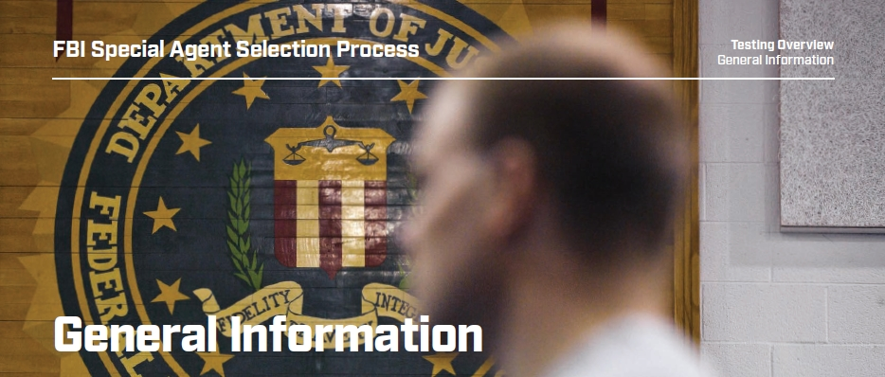

**Logistics and Guidelines**

When and Where:

Phase II tests are held at one of eight regional testing sites, located near airports in major U.S. cities. Complete

travel and booking guidelines will be provided prior to testing. Applicants will be reimbursed for travel expenses

upon completion of travel and timely submission of receipts.

Scheduling:

For the Phase II Writing Assessment, applicants will receive an invitation from PSI, on behalf of the FBI, to schedule the written portion of Phase II testing. Applicants will have up to 14 days from the date of invitation to schedule and complete this assessment. The Phase II Structured Interview is scheduled after the Writing Assessment has been completed.

What to Bring:

Candidates must bring a driver’s license to the assessment. If your driver’s license does not have a photo, you must

provide an additional form of photo identification.

What Not to Bring:

»» Reference materials (dictionaries, textbooks, etc.).

»» Pens and/or pencils (these will be provided).

»» Reading materials (books, magazines, newspapers, etc.).

»» Work-related materials.

»» Briefcases, backpacks and purses.

»» Papers (resumes, notification letters, notes, blank paper, etc.).

»» Cellular phones (alarms on watches must be turned off).

»» Other electronic devices (calculators, tape recorders, cameras, radios, etc.).

»» Firearms (if you are currently in a law enforcement position, you may not bring your firearm into the FBI space or the testing facility).

What to Wear:

**Writing Assessment:** Wear casual, comfortable clothing that is suitable for an office environment.

**Structured Interview:** Dress in a professional manner; business attire is recommended.

Test Time:

**Writing Assessment:** Approximately two and a half hours.

**Structured Interview:** Approximately one hour.

Basic Testing Rules:

**Tardiness** — Please arrive on time. If you are late, you will not be permitted to participate in testing.

**Eating/Drinking** — Eating and drinking is not allowed during testing.

**Smoking** — Smoking and chewing tobacco are not permitted during testing.

**Restroom Use** — You may not use the restroom during administration of the tests unless it’s an emergency.

**Cellphone Use** — You are not permitted to use a cellphone during the testing process.

**Time Limits\*** — Time limits are strictly enforced. When time has elapsed, you must immediately stop what you

are doing and await further instructions. Failure to comply will result in you being disqualified from the process.

*\*Special accommodations are available for those with a disability or impairment that will require a time extension.*

**Reasonable** **Accommodations** — The FBI provides reasonable accommodations to qualified individuals with

disabilities. If you believe you have a disability that will require special arrangements during the hiring process,

you may request a reasonable accommodation at any time by notifying your Applicant Coordinator. Each test in

the hiring process is evaluated differently. Therefore, you must submit a reasonable accommodation request for

each test, if needed. The decision to grant reasonable accommodations will be made on a case-by-case basis.

**Talking** — There will be no talking to other applicants once testing has begun.

**Cheating** — Any attempt to see another applicant’s answers; obtain assistance verbally or in writing; or record,

document or otherwise retain/discuss the questions/answers to the assessments is considered cheating.

Those caught cheating are discontinued from further consideration for the Special Agent position.

**Discussing the Tests** — Candidates are not permitted to discuss any part of the tests or interview questions with

anyone during or after the testing process. We discourage discussing your prospective FBI employment on any

social media or social networking sites. You should remain discreet about your application, including all interview

and testing information, during the entire FBI hiring process. This ensures other potential applicants are not given

an unfair advantage or disadvantage in the selection process. Applicants are required to sign a nondisclosure form

prior to the assessment. If an applicant is found to have violated this agreement, he or she will be disqualified.

**Leaving the Premises** — Candidates are not permitted to leave the testing premises during testing.

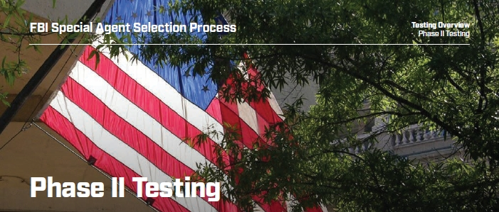

**Overview: Writing Assessment and Structured Interview:**

Applicants who successfully pass the Phase I test and successfully complete the Meet and Greet session will be assessed on their competitiveness for Phase II. Only candidates deemed Competitive will be invited to take the Phase II test.

The Phase II consists of two parts, a Writing Assessment and a Structured Interview. The Phase II Writing Assessment

must be completed first in order to be eligible to receive an invitation for the Structured Interview. Once you receive

an invitation for the Phase II Writing Assessment, you must sign up to take the test at a local PSI testing center and

complete it within 14 days of receiving the invitation. After completing the Phase II Writing Assessment, you will

receive an email invitation to the Phase II Structured Interview at one of the eight regional sites.

Applicants who fail Phase II testing may be eligible for one retest at least one year after their initial test date.

Not all applicants will be invited to retest.

Due to the overwhelming volume of Special Agent applicants, the FBI will only retest those applicants who meet

the Bureau’s current needs. Applicants who will exceed the age limit or who cannot be processed prior to their

37th birthday will not be retested.

Applicants interested in retesting for Phase II should reapply to the current Special Agent posting.

**Writing Assessment:**

The Writing Assessment exam is two and a half hours long and tests applicants’ ability to analyze data and prepare

two comprehensive reports.

At the start of the Writing Assessment, applicants will be given detailed instructions and other materials to use. Applicants will read about a fictional scenario and provide typed written reports.

Time will be provided for an optional break midway through the written exam.

**Writing Assessment Logistics:**

Like Phase I, the Phase II Writing Assessment is taken in a proctored environment offered by PSI. PSI’s

web-based registration and scheduling system allows you the flexibility to select the date, time and a test center

near you. Be sure to read all PSI emails carefully.

Your test will be administered by PSI’s trained proctors. Proctors and testing centers are not affiliated with the FBI.

Proctors will not answer position- or test-related questions. Contact your PFO’s Applicant Coordinator or recruiter

with any questions about the Special Agent position.

Before leaving for your scheduled appointment, check the Test Center Closures site to verify that your center is open.

Please arrive at the test center 15 minutes before the beginning of your Phase II test appointment. In most cases,

you will not be allowed to enter the center until 15 minutes prior to your appointment.

**Writing Assessment Tips:**

Before the Test Session:

»» Plan so you are well-rested before the test session.

»» Make sure you know the exact location and time of the test session, allow plenty of time to get to the test site use the restroom and relax.

»» Wear something comfortable; test sites may be slightly warm or cool so dress for a range of temperatures.

»» Reduce test anxiety and tension by breathing deeply and stretching before the test.

»» Start the test session with a positive attitude, determination to do your best and focus on what you do know, not on what you do not know

During the Test Session:

»» Read all the test instructions carefully and follow them exactly.

»» Be detailed and thorough in your writing.

»» Read each question and all the response options completely before choosing your answer.

»» Use only the facts provided – do not make up additional facts.

»» Follow grammatical rules and spell words correctly. Software to check spelling and grammar will not be available during the exam.

»» If you have time remaining at the end of each section, proofread your responses.

»» Try to stay relaxed; if you have trouble concentrating or become tense, pause and take a few deep breaths.

**Phase II Expirations:** Applicants are limited to two invitations before being deactivated unless a valid reason is

provided. Applicants must wait a minimum of 90 days from the expiration date before a new invitation will be issued.

Applicants who allow two Phase II invitations to expire without providing acceptable explanations will not be offered

other opportunities to test and will be deactivated from the Special Agent Selection System (SASS).

**Phase II No-Shows:** Applicants are limited to two no-shows before being deactivated unless a valid reason is

provided. Applicants must contact their Field Office Applicant Coordinator as soon as possible and provide a

written statement that details the reason for not taking the Writing Assessment. The FBI will ascertain the facts and

circumstances regarding an applicant’s failure to report for Phase II testing. If the reason is deemed acceptable, the

FBI will reschedule the applicant for testing. If the reason is not deemed acceptable, the applicant will be deactivated.

If there is a major test disturbance (power or internet outage, fire drill, etc.) declared by PSI, you may be given

the option to reschedule. If you have any concerns, contact your local Field Office Applicant Coordinator or

recruiter immediately.

**Structured Interview:**

The structured interview is one hour long and is administered by a panel of three Special Agents.

It follows the standard performance-based interview format for government interviews. The panel uses standardized

scoring criteria to measure the competencies that are important for the Special Agent position.

**Structured Interview Tips:**

»» Be yourself.

»» Remember that the interview panel knows no information about you beyond your name.

»» Provide detailed information when answering the questions. Provide the best examples of your skills and abilities, drawing from all your life experiences, not just the most recent ones.

»» The evaluators will be taking notes during the interview to assist them in documenting the results. Do not let this distract you.

»» Do not make assumptions about what the evaluators are seeking. The interview instructions are straightforward. There are no trick questions.

**Preparation:** Thoroughly read through the descriptions, statements and questions. Read carefully and attentively. Use the information from the description ONLY; do not introduce outside information to make the final selection. Pay attention to words such as MUST or ONLY and answer accordingly.

Test Preparation:

The FBI does not endorse any test preparation materials beyond what can be found on FBIJobs.gov or within this guide.

**Important:** An applicant will be deactivated for receiving advice beyond what is provided by the Applicant Coordinator and/or what is available at FBIJobs.gov. This includes information gathered from online sources or FBI employees.